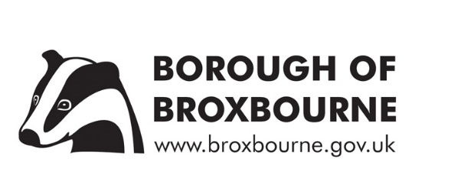

NOTICE OF DELAY TO THE AUDIT OF ACCOUNTS 2020/21

NOTICE is given that the external audit of the draft statement of accounts for the year ended 31 March 2021 has not yet been completed by the Council’s external auditors, EY LLP, due to the audit being rescheduled.

This situation is allowed for by Regulation 10, paragraph (2a) of the Accounts and Audit Regulations 2015. (: The Accounts and Audit Regulations 2015 (legislation.gov.uk)).

Therefore this notification explains, as per paragraph (2a), that the Council is not yet able to publish its audited 2020/21 final statement of accounts in line with deadline of 30 September 2021, as per paragraph (1).

The Audit and Standards Committee will consider the results of the 2020/21 audit, after which the Council will publish the final audited accounts.

Dated this 29th day of September 2021

Sandra Beck FCCA
Director of Finance
Borough of Broxbourne
Borough Offices
Bishops’ College
Churchgate
Cheshunt
Hertfordshire
EN8 9XG

